This Lesson is to accompany the

Superbook Creation Video—1/10/2021
Opening Activity: What’s in a Name?—Adapted from a Tru Lesson.
Invite the children to sit in a circle. Ask children to think of either a type of animal or an animal noise that matches the first letter of their name—for example, Darien Duck or Mooing Melissa. Ask one child to start by sharing her fun new name. Then move on to the next child in the circle, who will attempt to share the first child’s name as well as his own unique name. Continue around the circle this way, with the last child attempting to remember the name of every child before him.

DEVELOPMENTALLY SPEAKING
Because young children can feel uncomfortable when trying to remember facts in a group, encourage the kids to help each other by providing the noise their animal makes as a fun hint!
Praise and Worship Time: Play 2-3 Worship Songs. Encourage kids to join in with motions and singing along with the songs.
Prayer: Ask if there are any requests. Pray for us to have open hearts and minds to be able to learn and grow.
Following Praise and Worship/Prayer provide snacks for all children and play the Superbook video from RightNow Media.
Superbook-Season 1 Session 1

Storytelling
Bible Passage: Genesis 1—3

Supplies:
- Bibles
- Butcher paper (3 pieces, each approx. 2’)
- Tempera paint (various colors)
- Paintbrushes (several)
- Disposable cup
- Water
- Paper towels
- Tape
- Optional: markers or drawing chalk

Setup
Tape the pieces of butcher paper to the tables at the back of the room. Fill the cup with water and set it out along with the paint and paintbrushes. Optional: Instead of the paint supplies, set out the markers or chalk.

Teacher Script
Close your eyes for a moment and tell me what you see. Interact with responses. When I close my eyes, I can’t see anything—only darkness! Invite children to open their eyes.
The Big God Story tells us it was like this in the very beginning. Before God created the animals or the trees or the sun, everything was empty. There was nothing—nothing except for God. He is eternal. What does eternal mean? Invite responses.
It means that God has always been and will always be. Ever since creation, God has been working to tell His big story to the world and to invite every person to know and love Him.
Ever since creation, God has been working to tell His big story to the world and to invite every person to know and love Him.
Go to first piece of butcher paper and pick up a painting or drawing tool. In the beginning, God created the heavens and the earth.
Have children turn to Genesis 1 and follow along as you read verse 1. The Bible tells us God’s Spirit hovered over the waters. He was in control of everything that would happen—of everything that He would create.
On the first piece of butcher paper, draw blue wavy lines in the middle to represent the waters. Our powerful God was about to begin His big story that continues today!
God spoke, and with His words He began to create the world. God said, “Let there be light,” and there was light. Have children find the word “light” in verse 3. Still on the first butcher paper, fill in the top left portion with bright yellow.
God separated the light from the darkness, and He saw that it was good (verse 4). Fill in the top right portion with dark blue or black. God continued by creating the land and the seas. Draw a brown patch of land and a big body of water.
God also created plants—fruit trees and flowers and bushes. Move to second piece of butcher paper and draw a large fruit tree. God created the sun, the moon, and the stars. Return to first butcher paper and draw a sun, moon, and stars. He created animals on the land, fish in the sea, and birds in the air. Still on first paper, draw a few simple animal shapes.
Move to third piece of butcher paper. Then God created people in His image. And instead of speaking mankind into being, God used dirt from the ground to form a man. Draw simple figure of a man.
Then God breathed into the man, and he lived! Then God created a woman to be the man’s partner. He took a rib from the man and made a woman to be his wife. Draw simple figure of a woman.
Does anyone know the names of these first two people? Allow responses. That’s right—Adam and Eve.
God put Adam and Eve in the garden of Eden, a beautiful place where they could live and take care of the things God had created. In the garden, they enjoyed a perfect relationship with God and each other. God told Adam and Eve they could eat anything in the garden except the fruit from the Tree of Knowledge of Good and Evil. Go back to second piece of butcher paper and point to tree.
God told them that if they ate from this tree, they would die. God is eternal, which means He knows the beginning and the end. He didn’t want harm to come to Adam and Eve.
One day a snake spoke to Eve. Still on second piece of paper, draw a snake near the tree. Can you hear him coming? Invite children to make hissing sounds with you.
The snake told Eve that the things God had said about the Tree of Knowledge of Good and Evil weren’t true. The snake told Eve that God was trying to keep her from being like God—the eternal One. Eve believed the snake. She took a piece of fruit and ate it. Then she gave a piece of fruit to Adam, and he took a bite too. Draw a piece of fruit with a bite mark in it.
When Adam and Eve ate the fruit, they disobeyed God, and sin entered the world. Their choice broke their relationship with God. Draw a jagged line down middle of paper.
Adam and Eve’s choices broke the relationship between God and people. But because God is eternal, He made a plan to send His Son Jesus to die for our sins so we could be in relationship with Him forever. On third piece of paper, draw a cross.
Jesus took the punishment for our sin. God loves us so much that He invites each of us to know Jesus and accept His forgiveness for our sins. Still on third piece, draw a heart.
God is eternal. He has always existed and will always exist! He created all that we can see, taste, touch, hear, and smell. He created you and me. He invites you, me, and everyone to be a part of The Big God Story. Share a personal story about how you’ve seen the eternal God in creation.

Discussion Questions
- What existed before creation? Genesis 1:1
- What did God create? Genesis 1:3–27
- How did God create the world? Genesis 1:3–27
- How was God’s creation of man and woman different from His creation of everything else? Genesis 2:7, 21–22
- What happened when Adam and Eve disobeyed God? Genesis 3:7–19
- What did God do so we can be in relationship with Him? John 3:16

Remember Verse
Before the mountains were born or you brought forth the whole world, from everlasting to everlasting you are God. Psalm 90:2

Game: Word Scramble

Supplies
- Paper (20 sheets)
- Market
- Optional: additional paper (20 more sheets)

Setup
Write each word of the verse and the verse reference on a separate sheet of paper. (If you have a large group of kids, write the verse again on another 20 sheets of paper.) Scramble the papers.

Teacher Script
Talk with your children about the Remember Verse and how it relates to today’s lesson point—God Is Eternal. Then give the kids the sheets of paper and invite them to put the words in the correct order on the floor. Once they have the words in order, they can read the Remember Verse out loud. Then have the children scramble the words again and repeat the process. Keep playing until the kids have memorized the verse.

Respond
Children process what the Holy Spirit has been teaching them and respond to God through individual and collaborative worship and various forms of play, including interactive games, activities, experiments, and more.

Craft: God’s Great Creation

Supplies
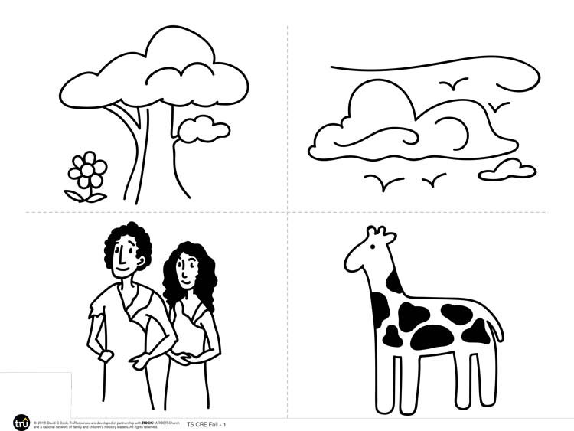
- Creation images
- Scissors
- Poster board (1 sheet, black)
- Crayons or colored pencils
- Tape or glue

Prepare Ahead
Print the Creation images and cut them apart. Make sure you have one image for each child.

Teacher Script
God is eternal. He created the world and everything in it. No one else helped God create the world. He has always existed, and He is the one true God who rules over everything. Whenever we see a mountain or a beautiful flower or a buzzing bee, we can know that God created its beauty. What is your favorite part of God’s creation? Allow responses.
God also created you and me. The Bible says that God created us in His image, and when we accept Jesus, the Holy Spirit helps us become more like Him (Colossians 3:9–10). How does it make you feel to know that God created you in His image? Allow responses.
It’s amazing that even after people chose to disobey God, He provided Jesus so we could have a perfect relationship with Him again. When we accept Jesus’ gift of salvation, God cleans us from all our sin and invites us to be a part of The Big God Story!
It’s amazing that even after people chose to disobey God, He provided Jesus so we could have a perfect relationship with Him again.
Encourage your kids to respond to the ways God has shown His grace and love in their lives. Invite each child to take one of the Creation images and color it with colored pencils or crayons. Then, in the space around the image, they can either write or draw a word that represents one thing they’re grateful for about God. It could be something they love about His creation, or a special person He has placed in their lives, or one of His characteristics—His mercifulness or eternal nature or love.
Then invite the children to come up one at a time and tape or glue their images of creation to the black poster board. As each child places her image on the poster, invite her to share what she wrote or drew. Together the kids’ images will create a beautiful collage of God’s creation and His wonderful characteristics. Also encourage kids to share with their families what they chose to express about God.

Game: Let There Be Light
Lead the children in a fun game to help get them moving and thinking about our great God who creates something out of nothing. Tell the kids you’re going to play a game similar to Simon Says, and they’ll need to pay close attention!
There will be three possible things you will ask them to do. If you say,“God said, ‘Let there be light!’” they should jump up and wave their hands over their heads. If you say,“God said, ‘Let there be water!’” they should move their arms in a swimming motion. If you say,“God said, ‘Let there be animals!’” they should make an animal noise or move like an animal. In order to do the action, the kids need to hear you say,“God said.” If you don’t say this first, the kids should remain still. Any kids who start doing the action anyway are out. Play until one child remains, and feel free to play a few rounds.
- What was easy about this game? What was hard?
- How is this game similar to listening for God?
- How does God talk to us today?
Our God simply spoke and things started happening. All of creation listened to what God had to say. We can continue listening for God’s voice because we know we’re a part of The Big God Story, which began with creation and continues today!

